Ordenamiento Javier
Respuesta 4
Ordenamiento por selección
L = [-4 , 2 , 8 , 7]

Paso 1

i = 0
j = i+1
pos_min = i
Comparo L[j] < L[pos_min]
j = 2
Comparo L[j] < L[pos_min]
j = 3
Comparo L[j] < L[pos_min]
j = 4
Intercambio L[i] < L[pos_min]

Paso 2

i = 1
j = i+1
pos_min = i
Comparo L[j] < L[pos_min]
j = 3
Comparo L[j] < L[pos_min]
j = 4
Intercambio L[i] < L[pos_min]

Paso 3

i = 2
j = i+1
pos_min = i
Comparo L[j] < L[pos_min]
j = 4
Intercambio L[i] < L[pos_min]

Respuesta 4
Ordenamiento por Inserción
lista = [10,3,2,1]

Paso 1 : objetivo insertar el 3

Comparo 3 con 10 → intercambio
[3,10,2,1]

Paso 2 : objetivo insertar el 2

Comparo 2 con 10 → intercambio
[3,2,10,1]
Comparo 2 con 3 → intercambio
[2,3,10,1]

Paso 3 : objetivo insertar el 1

Comparo 1 con 10 → intercambio
[2,3,1,10 ]
Comparo 1 con 3 → intercambio
[2,1,3,10]
Comparo 1 con 2 → intercambio
[1,2,3,10]

Respuesta 5

Dado el mejor caso y peor caso:

selección sort: en una lista el algoritmo recorre len(array)-1 y interno len(array) -= 1

Mejor Caso
python3 ss.py

[1, 2, 3, 4]
while_externo 1
while_inter 1
while_inter 2
while_inter 3
while_externo 2
while_inter 1
while_inter 2
while_externo 3
while_inter 1
[1, 2, 3, 4]
Peor Caso
python3 ss.py

[4, 3, 2, 1]
while_externo 1
while_inter 1
while_inter 2
while_inter 3
while_externo 2
while_inter 1
while_inter 2
while_externo 3
while_inter 1
[1, 2, 3, 4]

selección sort: en una lista ordenada y desordenada el algoritmo recorre

Mejor Caso
insertion_sort.py

[1, 2, 3, 4]
while_externo 1
while_externo 2
while_externo 3
[1, 2, 3, 4]

Peor Caso
insertion_sort.py

[4, 3, 2, 1]
while_externo 1
while_inter 1
while_externo 2
while_inter 1
while_inter 2
while_externo 3
while_inter 1
while_inter 2
while_inter 3
[1, 2, 3, 4]

Respuesta 6

selección sort: en una lista ordenada el algoritmo recorre len(array)-1
python3 -m timeit -n 1000 -s 'from ss import selection_sort' 'selection_sort([1,2,3,4,5])''

Mejor caso ss
lista = list(range(200))
lista
1000 loops, best of 3: 3.69 usec per loop 5 elem
1000 loops, best of 3: 10.9 usec per loop 10 elem
1000 loops, best of 3: 22.4 usec per loop 15 elem
1000 loops, best of 3: 36.8 usec per loop 20 elem
1000 loops, best of 3: 85.6 usec per loop 30 elem
1000 loops, best of 3: 205 usec per loop 50 elem
1000 loops, best of 3: 399 usec per loop 70 elem
1000 loops, best of 3: 862 usec per loop 100 elem
1000 loops, best of 3: 2.99 msec per loop 200 elem

Peor caso ss
lista = list(range(200))
lista[::-1]
1000 loops, best of 3: 3.74 usec per loop 5 elem
1000 loops, best of 3: 12.4 usec per loop 10 elem
1000 loops, best of 3: 24.1 usec per loop 15 elem
1000 loops, best of 3: 41 usec per loop 20 elem
1000 loops, best of 3: 87.3 usec per loop 30 elem
1000 loops, best of 3: 218 usec per loop 50 elem
1000 loops, best of 3: 415 usec per loop 70 elem
1000 loops, best of 3: 813 usec per loop 100 elem
1000 loops, best of 3: 3.37 msec per loop 200 elem
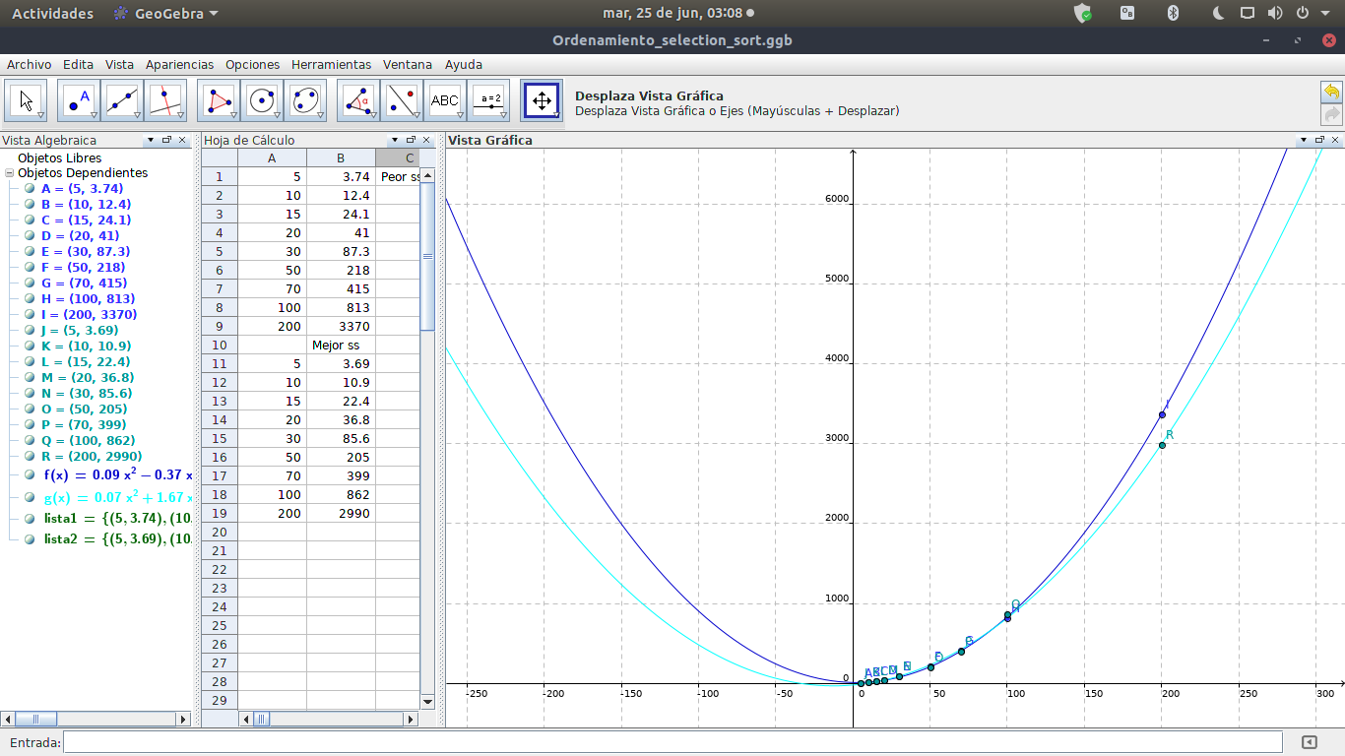
Insertion sort
python3 -m timeit -n 1000 -s 'from insertion_sort import insertion_sort' 'insertion_sort([0,1,2,3,4])'

Mejor caso is
lista = list(range(200))
lista
1000 loops, best of 3: 1.08 usec per loop 5 elem
1000 loops, best of 3: 2.15 usec per loop 10 elem
1000 loops, best of 3: 3.02 usec per loop 15 elem
1000 loops, best of 3: 3.97 usec per loop 20 elem
1000 loops, best of 3: 5.73 usec per loop 30 elem
1000 loops, best of 3: 9.48 usec per loop 50 elem
1000 loops, best of 3: 14.5 usec per loop 70 elem
1000 loops, best of 3: 19.4 usec per loop 100 elem
1000 loops, best of 3: 39.3 usec per loop 200 elem

Peor caso is
lista = list(range(200))
lista[::-1]
1000 loops, best of 3: 2.8 usec per loop 5 elem
1000 loops, best of 3: 9.68 usec per loop 10 elem
1000 loops, best of 3: 23.9 usec per loop 15 elem
1000 loops, best of 3: 36 usec per loop 20 elem
1000 loops, best of 3: 80.6 usec per loop 30 elem
1000 loops, best of 3: 221 usec per loop 50 elem
1000 loops, best of 3: 409 usec per loop 70 elem
1000 loops, best of 3: 873 usec per loop 100 elem
1000 loops, best of 3: 3.39 msec per loop 200 elem
